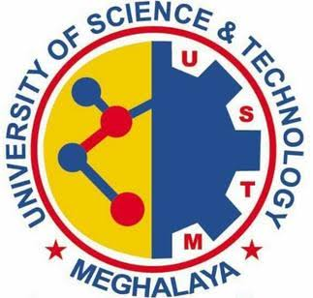

**UNIVERSITY OF SCIENCE & TECHNOLOGY**

**MEGHALAYA**

**Department of Computer Science & Electronics**

**CERTIFICATE FROM HOD**

This is to certify that the project work, entitled

“**STUDENT INFORMATION SYSTEM**”

is carried out by

**Gaurab Roy (17/BCA/44) & Rupanjan Sarkar (17/BCA/12)**,

in partial fulfillment for the award of the degree of BCA Semester 4 of

**University of Science & Technology, Meghalaya**.

They have work under the supervision of **Dr. Kanak Chandra Bora**, Assistant Professor, **Department of Computer Science and Electronics.**

**Techno City, Kling Road, Baridua, 9th Mile, Ri-Bhoi, Meghalaya-793101**

**Ph: 0361-2895030 (Telefax), E-mail:** [**csedept.ustm@gmail.com**](mailto:csedept.ustm@gmail.com)**, Website: www.ustm.ac.in**

**Dr. Bhairab Sarma**

Head, Department of Computer Science & Electronics

**University of Science & Technology, Meghalaya**